The 2025 National Federation of the Blind of Nevada State Convention
Friday April 25 until Sunday April 27,2025
Palace Station Hotel and Casino
2411 W. Sahara Ave
Las Vegas, NV 89102

The National Federation of the Blind knows that blindness is not the characteristic that defines you or your future. Every day we raise the expectations of blind people because low expectations create obstacles between blind people and our dreams. You can live the life you want; blindness is not what holds you back.

National Representative; Jim Marks
Jim Marks serves as the President of the NFB of Montana and on the National Board of Directors of the NFB. Jim lives in Helena with his wife, Kathy. He works as the Program Director of Rocky’s Agency on Aging.

National Federation of the Blind of Nevada Officers and Directors
President: Mark Tadder
1st Vice President: Ramona Coker
2nd Vice President: Becky Jayakumar
Secretary: Frida Aizenman
Treasurer: Chun Chao
Board Member 1: Regina Mitchell
Board Member 2: Heather Destefano
Board Member 3: Susan Moore
Board Member 4: Mario Castillo

Convention Registration Costs and Details
Convention registration will ensure you buy a ticket into our Friday night Reception
You will also be automatically entered into the many door prize drawings that will occur throughout the convention proceedings. You must be in the room to claim your prize.

$25 Convention registration will open from March 1 and run until April 26 and will be available at the door on Convention Saturday until 11am
To be able to order food including options for Saturday and Sunday Breakfast, Saturday Lunch and our Fabulous Saturday Banquet YOU MUST REGISTER ONLINE BEFORE MIDNIGHT ON APRIL 15
Meal Package options will not be available after April 15

Friday, April 25, 2025

6:00PM - 10:00PM The Silver State Welcome Reception
Reconnect with your Nevada Federation family members for Fellowship, fantastic appetizers and fun and games to kick off the 2025 Nevada State Convention

Saturday, April 26, 2025
8:00AM - 9:00AM Continental Breakfast
Available for attendees who pre-purchased during Registration

9:00AM – 9:15AM Welcome Ceremonies
National Anthem - Sergeant Greg Curtin
Invocation - Stan Mitchell
NFB Pledge (found at end of agenda)

9:15AM – 9:45AM National Report
Jim Marks, NFB National Representative

9:45AM – 10:00AM Nevada Affiliate Report
Mark Tadder, National Federation of the Blind of Nevada President

10:00AM – 10:20AM Legislative Update
Becky Jayakumar, NFB Nevada Legislative Director

10:20AM – 10:35AM STEM2U Program Info
Learn about our two upcoming STEM2U Academy sessions taking place in Pahrump on May 24 and Reno/Sparks on August 16 by coordinator and affiliate board member Susan Moore

10:35AM – 10:45AM Morning Break

10:45AM – 11:00AM Talking Books and BARD Updates
Brett Silver, Nevada State Library

11AM – 11:15AM Chapter Reports
Las Vegas Chapter, Becky Jayakumar, Chapter President
Southern Nye Chapter, Deloris Joyner, Chapter President
Northern Chapter, Ramona Coker, Chapter President

11:15AM – 11:45AM Amerability Presentation: Work-Play-Create
Amerability are new to Nevada but not blindness, owner and CEO Murray Elbourn will present the wide array of programs and activities his dynamic organization is now providing here in Nevada.

11:45PM – 12:00PM NFB NewsLine Program Update
Mario Castillo, will discuss the latest and greatest updates on our News service designed by and for the blind.

12:00PM – 1:30PM Lunch
Attendees who Pre-ordered their box lunch will receive them and all attendees will have time to meet with our Venders in the vender room

General Session II. 1:30PM– 5PM

1:30PM – 1:35PM Reconvening and Announcements

1:35PM – 2:00PM Being Prepared for an Emergency
In times of disaster, you will want a plan. Skye Dunfield, emergency manager, will provide tips, guidance and answer questions about the essentials surrounding these types of events.

2:00PM – 2:25PM Breakouts
There will be 3 breakout sessions to which attendees will rotate through
Breakout Alpha-Long white cane travel: A critical first tool to learn when faced with vision loss, is the long white cane. Ryan O’Neill will share why this tool is so important in increasing your independence, how to hold and use the cane, and things to think about when moving and orienting yourself in familiar and new environments.
Breakout Bravo – Using Meta Glasses - Listen to GPS directions, take a picture of your surroundings and get it described in seconds, ask questions about locations and things around you and you’ve got some of the things that Metta glasses can do for the blind. Havander Davis, will facilitate a discussion and demonstration on this hands-free technology.
Breakout Charlie – daily living skills – Practical tips and tricks Raquel O’Neil. Join this breakout to exchange and learn about everyday life hacks that blind people use to accomplish tasks like cooking, cleaning, and personal care.

2:30 – 3:00PM Adjustment to vision loss
Raquel O'Neill, LCSW, CVRT, and Pedro Navarro, LCSW -finding life after vision loss is difficult but you are not alone. Mental health professionals who have lived with vision loss will explain some stages you may experience, share tips for building optimism and resilience, and close with a short mindfulness/grounding exercise.

3:00PM – 3:25PM Breakout Round 2: Join in the 2nd breakout listed above.

3:30PM – 4:00PM Resolutions Committee Meeting
The 5 Prospective Resolutions will be read and commented on by the Resolution Committee Board, before potentially being moved to be voted on Sunday by the full convention. Resolutions are critical as they define the advocacy efforts to be focused on until the next NFB Nevada Convention.

4:00PM – 4:30pm Breakout Round 3 Join the final breakout session listed above.

4:30PM – 4:45PM How to harness use of AI prompting for the blind
A new hot topic has hit mainstream, and now blind people are discovering how artificial intelligence, AI can help us. Share in listening to Orlando Johnson, as he facilitates a discussion on this trending topic.

4:45PM – 5:00PM Announcements, Wrap-up and Adjournment

7:00PM - 10:00PM Dinner Banquet

In Federation fashion, come dressed to impress as we celebrate year 2025 with awards ceremony and keynote address by National Representative, Jim Marks.
Our banquet will also include great NFB fellowship, door prizes, our famous live auction baskets, and presentation of the $3,000 and $2,000 student scholarship winners.

Sunday April 27, 2025

8:00AM - 9:00AM Continental Breakfast for attendees who pre-registered

9:00AM – 12:00PM Business Meeting
NFB Nevada Board Meeting
Treasurer’s Report - Chun “Allen” Chao, Treasurer
Membership Report – Ramona Coker, Membership Director
Resolutions – Frida Aizenman, Resolutions Chair - The Convention will vote on Resolutions as presented at prior Committee Meeting
Nomination Committee Presentation – Mona Coker, Chair
Elections for Board of Directors - 1st, 2nd, 3rd and 4th Board Directors will be elected for a two year term as indicated in our State constitution. Only members in good standing may vote or run for office. Note that no proxy voting is allowed.

12:00PM or end of business Adjourn

Convention Sponsors

Platinum

Amerability,
Work-Play-Create
Amerability are new to Nevada but not blindness, our owner and CEO, Murray Elbourn comes from Sydney, Australia but is now in Las Vegas assisting BSBVI clients of all ages both youth and adult in the following activities and opportunities.
Music, Blind Sports, AI for the blind and low vision, Employment and Training, residency transition and independent living skills.
Search Amerability services for our instagram group or Facebook group.

White Cane
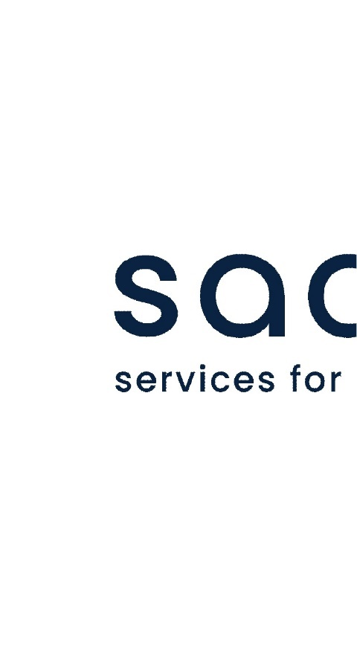

Saavi Services for the Blind
WE BELIEVE THAT it doesn’t matter what you can see, it matters what you can do.
www.Saavi.us

The NFB Pledge
I pledge to participate actively in the efforts of the National Federation of the Blind to achieve equality, opportunity, and security for the blind; to support the policies and programs of the Federation; and to abide by its constitution.

